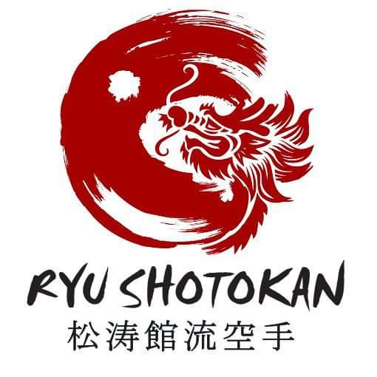

Dear Parents,

With only 1 week left of term, we now have limited space left. Our classes start back for the new term on the 6th January 2026. We now have limited slots which will be available now on a first come, first served basis. If you would like a slot for your child, then please contact us on 07493810010 or ryushotokankarate@hotmail.com
Sessions will run from 15:30 – 16:30 every Tuesday and the cost for the term is £25.
Classes are instructed by international coach and former international athlete Mike Carr 4th Dan head coach of Ryu Shotokan Karate. Sensei Mike Carr has a wealth of knowledge having been a former international competitor and is the current British Champion. He is also enhanced DBS checked, safeguarding trained, first aid trained and a current EKNGB registered and WKF registered coach.
Our sessions help with confidence, coordination, discipline, social interaction, and mental and physical wellbeing. Doing this in a safe and controlled environment to help encourage growth and fun.
Ryu Shotokan has been running for 12 years. In that time, it has created regional, national British, International, commonwealth, World and European champions. As well as that, Ryu boasts England Squad members.
If you can’t attend on a Tuesday after school, we run a Thursday class at The Monkton, Penkridge 6pm till 7pm.

Many thanks

Sensei Mike Carr 4th Dan
Head Coach
Ryu Shotokan

