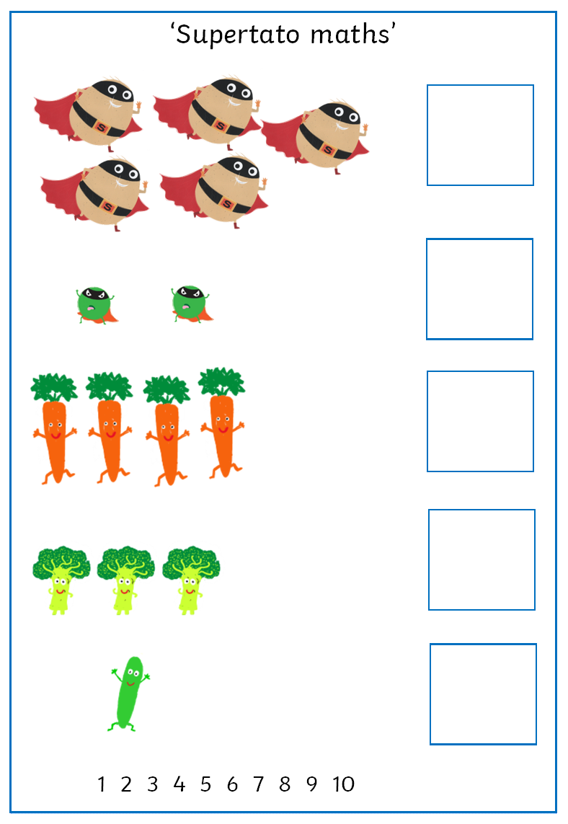

Count the number of vegetables in each group and match the correct numeral to the quantity.

Can you have a go at writing the numbers yourself.